Glow Shine Academy Secondary School

**Khairahani-8, Parsa, Chitwan**

**First Terminal Examination - 2082**

**Subject: Art**

**Class: Two F.M.:25**

**Name: Roll n****o.:**

**Q.N.1) Colour the picture. [10]**

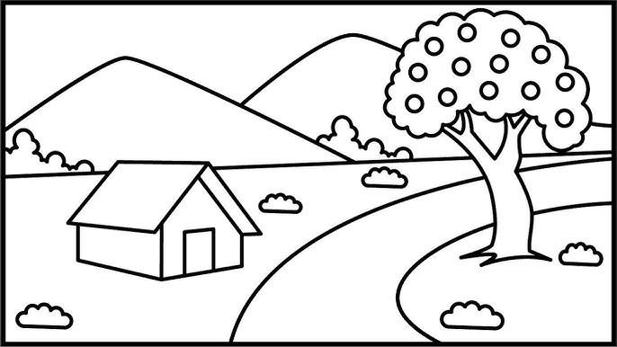

Q.N.2) Draw a picture of an ice-cream and colour it. [15]